PRACTICAL GP

PRACTICAL 5

OPEN THE PREVIOUS MODEL AND SELECT POINT LIGHT

IN THE RIGHT PANEL CHANGE PAOINT TO SPOT

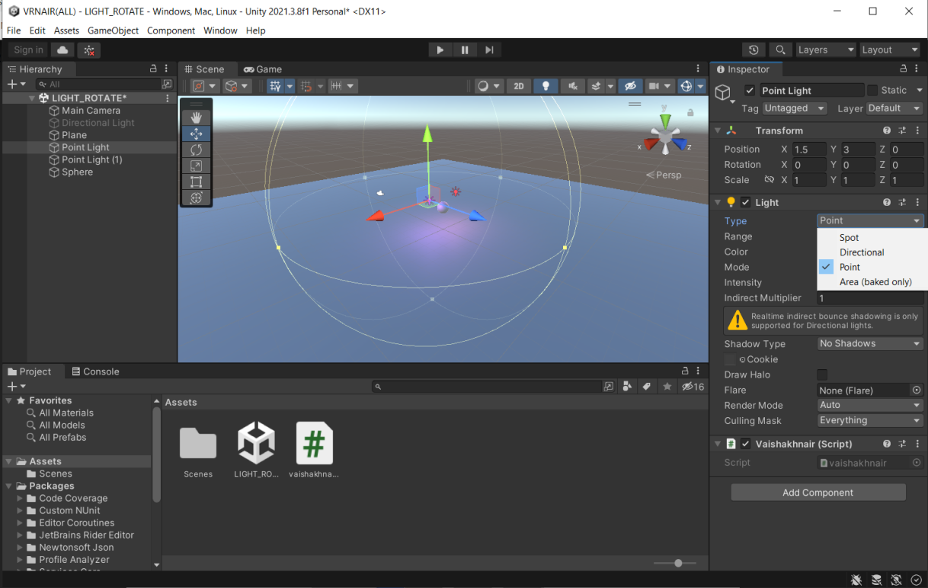

CHANGE THE ROTATION X=90, SPOT ANGLE=80

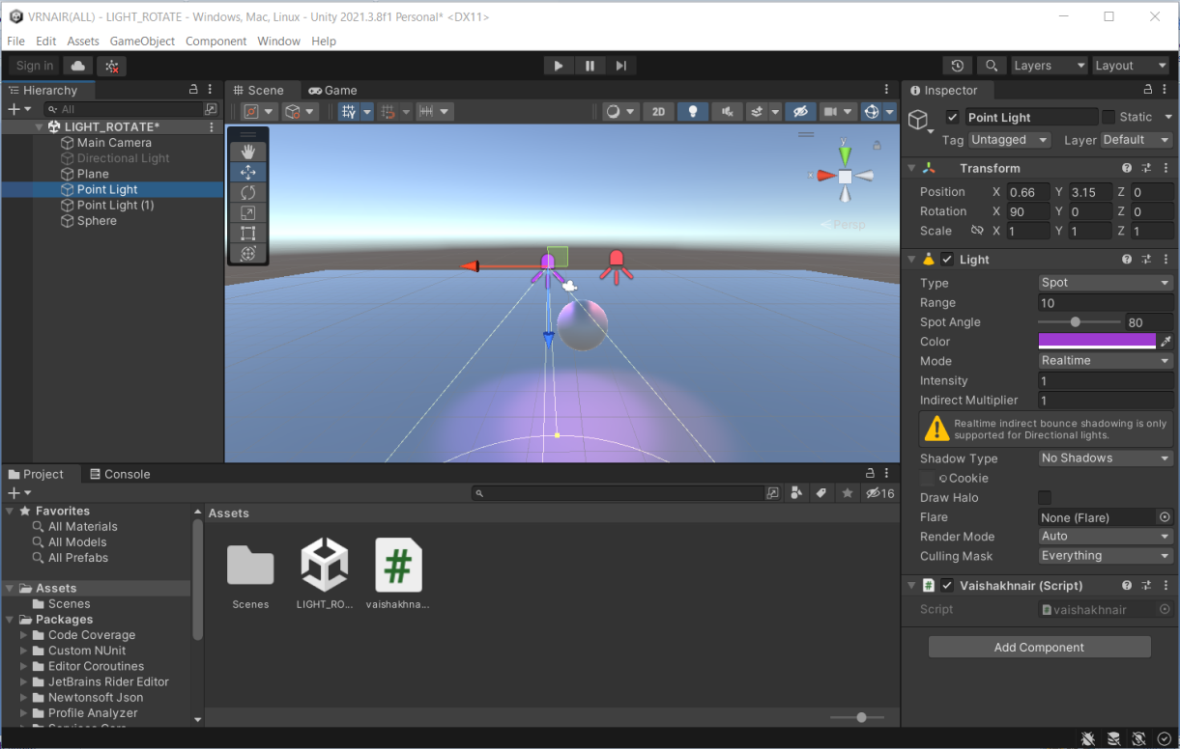

RUN THE APPLICATION

